**How to Convert Presentation to Video with PowerPoint 2016-2010**

How to convert your PowerPoint show presentation to a video file? here is a tutorial on how to convert PowerPoint file (.ppsx) into MPEG or MP4 video which can be played back on any media player, just in several minutes without any software!

**IMPORTANT: Check your recorded audio narration, playback the PowerPoint Presentation Slide Show or Video file to verify audio recorded successfully.**

**Recommended maximum file size: 40 MB.**

## **Option 1: Save Your PowerPoint Presentation as a PowerPoint Show (.PPSX)**

Save as PPSX format, and when someone opens the file, it is displayed in full screen on the slide for immediate viewing.

Step 1: On the **File** menu, select **Save As**.

Step 2: Choose the folder location where you want to store your PowerPoint Show file.

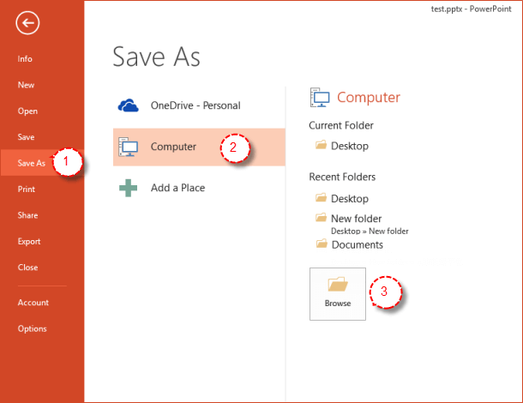

Step 3: In the **Save as type** box, choose **PowerPoint Show (*.ppsx)**.

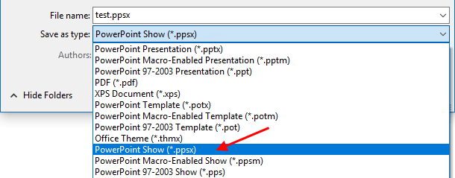

**IMPORTANT: Check your recorded audio narration, playback the PowerPoint Presentation Slide Show or Video file to verify audio recorded successfully.**

## **Option 2: Export Your Presentation to a video file (.MP4) in PowerPoint**

Here is a tutorial on how to convert PowerPoint file (.ppsx) into MPEG or MP4 video which can be played back on any media player, just in several minutes without any software!

Microsoft PowerPoint has a feature that allows users to export and save PowerPoint as a WMV or MP4 format video.

Step 1: Open your PPTX file in PowerPoint. Choose **File** >**Export**, then click**Create a Video**.

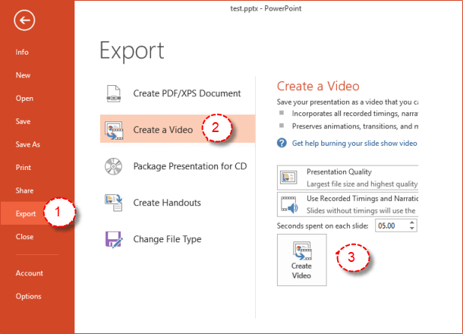

Step 2: In the **File name** box, enter a file name for the video, and then click **Save**.

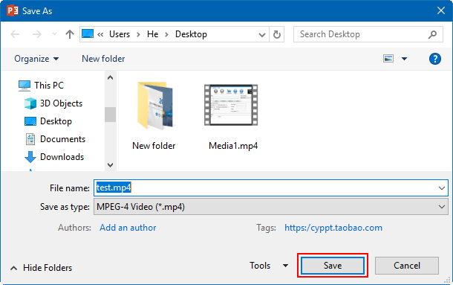

That's it. To play your newly-created video, go to the designated folder location, and then double-click the file.

## **IMPORTANT: Check your recorded audio narration, playback the PowerPoint Presentation Slide Show or Video file to verify audio recorded successfully.**

**Recommended maximum file size: 40 MB.**

**Option 3: Convert PPSX to MP4 Online**

If your computer does not have Microsoft PowerPoint installed, you can use a PPSX to MP4 converter to convert PPSX to MP4 online for free.

Step 1: Open this [free online PPSX to video converter](https://video.online-convert.com/convert-to-mp4) page.

Step 2: Click the **Select a file** button to browse and add source PPSX file.

Step 3: After adding source PPSX file, you could view the PPSX file size and name. Set output video quality under the **Quality**, select output video format (.mp4) and determine the video size(resolution) on the right.

Step 4: After settings, click the "**Convert**" button on this page.

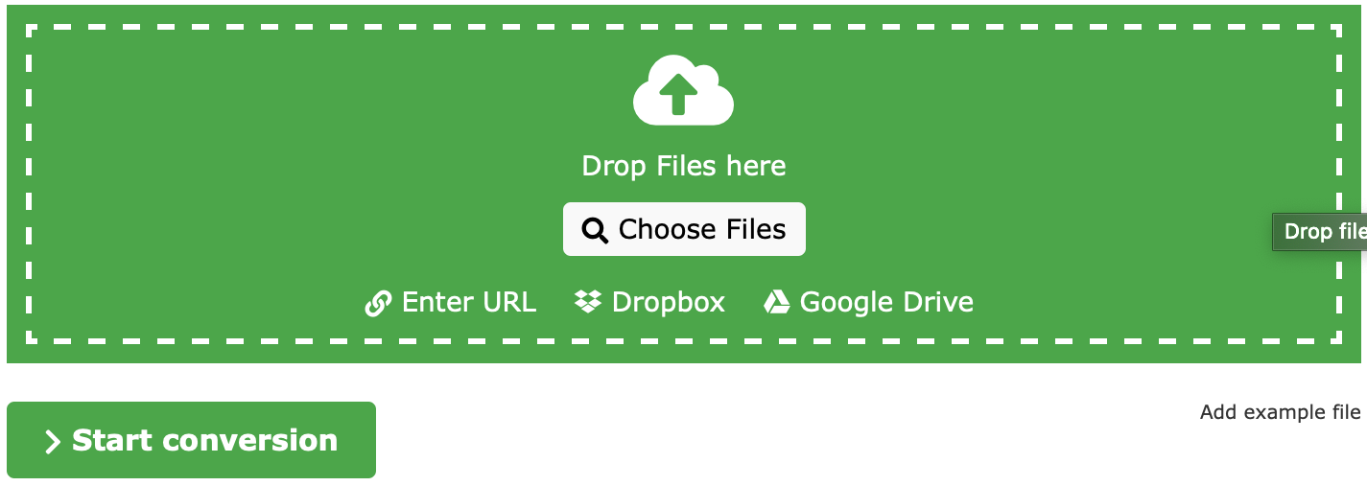

Step 5: After converting, you could download the converted PPTX files (now in MP4 format) to your computer.

## **Please playback the PowerPoint Presentation Slide Show or Video file to verify audio and video recorded successfully.**

**Recommended maximum file size: 40 MB.**